HOW TO COMPLETE APPLICATION FOR
AN OHIO DRIVER LICENSE OR ID CARD (DL/ID)
BMV5745
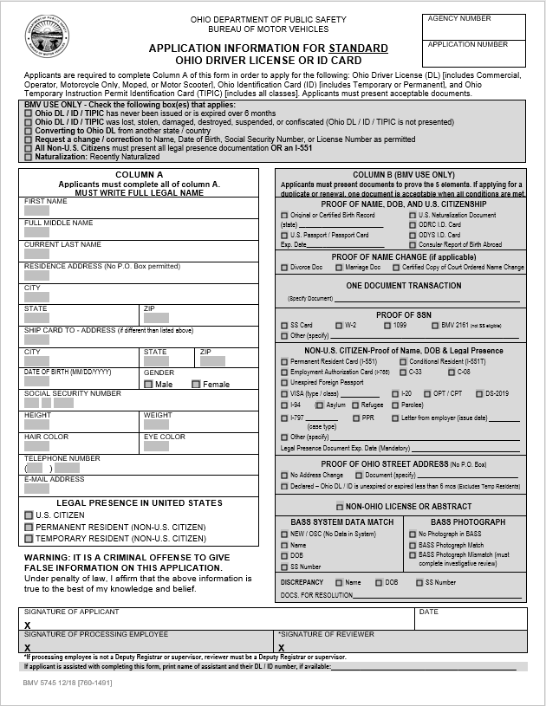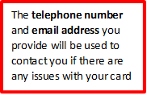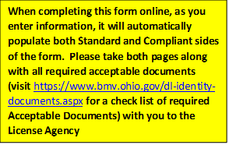
Check U.S. Citizen if you were born in the U.S., Puerto Rico or any other U.S. territory, or you are a naturalized citizen
Social security number (SSN) listed on this form must match the number listed on the document used to prove SSN
Enter your current address
SHIP TO address information is needed only if it is different from your residential address (You must be an Ohio resident to purchase an Ohio DL/ID)
Enter required personal information in Column A ONLY
Use your legal name displayed on your birth certificate, passport, or marriage license (use the document that displays your current name)

As a customer, you are required to complete a BMV5745 to obtain a DL/ID card for the following reasons:
- First time issuance of any card type (driver license, ID, or Out of State conversion)
- First time issuance of a Compliant card
- Replacement of lost, stolen, damaged, suspended, or confiscated card
- Information change (name, date of birth or SSN)
- Current card is expired over 6 months
- Non-US Citizen or recently naturalized citizen

 | OHIO DEPARTMENT OF PUBLIC SAFETY  BUREAU OF MOTOR VEHICLES  APPLICATION INFORMATION for standard  OHIO DRIVER LICENSE or ID CARD | Agency Number
 |  | APPLICATION NUMBER
Applicants are required to complete Column A of this form in order to apply for the following: Ohio Driver License (DL) [includes Commercial, Operator, Motorcycle Only, Moped, or Motor Scooter], Ohio Identification Card (ID) [includes Temporary or Permanent], and Ohio Temporary Instruction Permit Identification Card (TIPIC) [includes all classes]. Applicants must present acceptable documents.
BMV USE ONLY - Check the following box(es) that applies:
Ohio DL / ID / TIPIC has never been issued or is expired over 6 months
Ohio DL / ID / TIPIC was lost, stolen, damaged, destroyed, suspended, or confiscated (Ohio DL / ID / TIPIC is not presented)
Converting to Ohio DL from another state / country
Request a change / correction to Name, Date of Birth, Social Security Number, or License Number as permitted
All Non-U.S. Citizens must present all legal presence documentation OR an I-551
Naturalization: Recently Naturalized

COLUMN A
Applicants must complete all of column A.
MUST WRITE FULL LEGAL NAME
First Name

Full Middle NAME

CURRENT LAST NAME

RESIDENCE ADDRESS (No P.O. Box permitted)

City

STATE | Zip
SHIP CARD TO - ADDRESS (if different than listed above)

City | state |  | zip
date of birth (MM/DD/YYYY) | Gender  Male Female
SOCIAL SECURITY NUMBER

HEIGHT | WEIGHT
HAIR COLOR | EYE COLOR
Telephone Number
( )
E-mail Address

LEGAL PRESENCE IN UNITED STATES
U.S. CITIZEN
PERMANENT RESIDENT (NON-U.S. CITIZEN)
TEMPORARY RESIDENT (NON-U.S. CITIZEN)
WARNING: IT IS A CRIMINAL OFFENSE TO GIVE FALSE INFORMATION ON THIS APPLICATION.
Under penalty of law, I affirm that the above information is true to the best of my knowledge and belief.
COLUMN B (BMV USE ONLY)
Applicants must present documents to prove the 5 elements. If applying for a duplicate or renewal, one document is acceptable when all conditions are met.
PROOF OF NAME, DOB, AND U.S. CITIZENSHIP
Original or Certified Birth Record  (state)  U.S. Passport / Passport Card  Exp. Date |  | U.S. Naturalization Document  ODRC I.D. Card  ODYS I.D. Card  Consular Report of Birth Abroad
PROOF OF NAME CHANGE (if applicable)
Divorce Doc Marriage Doc Certified Copy of Court Ordered Name Change
ONE DOCUMENT TRANSACTION
(Specify Document)
PROOF OF SSN
SS Card W-2 1099 Pay Stub BMV 2161 (not SS eligible)
Other (specify)
NON-U.S. CITIZEN-Proof of Name, DOB & Legal Presence
Permanent Resident Card (I-551) Conditional Resident (I-551T)
Employment Authorization Card (I-766) Unexpired Foreign Passport
VISA (type / class) I-20 OPT / CPT DS-2019
I-94 ( Asylum Refugee Parolee)
I-797 PPR
(case type)
Other (specify)
Legal Presence Document Exp. Date (Mandatory)
PROOF OF OHIO STREET ADDRESS (No P.O. Box)
No Address Change Document (specify)
Declared – Ohio DL / ID is unexpired or expired less than 6 mos (Excludes Temp Residents)
NON-OHIO LICENSE OR ABSTRACT
BASS SYSTEM DATA MATCH |  | BASS PHOTOGRAPH
NEW / OSC (No Data in System)  Name  DOB  SS Number |  | No Photograph in BASS  BASS Photograph Match  BASS Photograph Mismatch (must complete investigative review)
DISCREPANCY Name DOB SS Number
DOCS. FOR RESOLUTION

Signature of Applicant (Must be signed in front of the processing employee)  X |  | Date
Signature of Processing Employee  X | *Signature of REVIEWER  X
*If processing employee is not a Deputy Registrar or supervisor, reviewer must be a Deputy Registrar or supervisor.

If applicant is assisted with completing this form, print name of assistant and their DL / ID number, if available:

 | OHIO DEPARTMENT OF PUBLIC SAFETY  BUREAU OF MOTOR VEHICLES  APPLICATION INFORMATION for compliant  OHIO DRIVER LICENSE or ID CARD | Agency Number
 |  | APPLICATION NUMBER
Applicants are required to complete Column A of this form in order to apply for the following: Ohio Driver License (DL) [includes Commercial, Operator, Motorcycle Only, Moped, or Motor Scooter], Ohio Identification Card (ID) [includes Temporary or Permanent], and Ohio Temporary Instruction Permit Identification Card (TIPIC) [includes all classes]. Applicants must present acceptable documents.
BMV USE ONLY - Check the following box(es) that applies:
Compliant Ohio DL / ID / TIPIC has never been issued or is expired over 6 months
Ohio DL / ID / TIPIC was lost, stolen, damaged, destroyed, suspended, or confiscated (Ohio DL / ID / TIPIC is not presented)
Converting to Compliant Ohio DL from another state / country
Request a change / correction to Name, Date of Birth, Social Security Number, or License Number as permitted
All Non-U.S. Citizens must present all legal presence documentation OR an I-551
Naturalization: Recently Naturalized

COLUMN A
Applicants must complete all of column A.
MUST WRITE FULL LEGAL NAME
First Name

Full Middle NAME

CURRENT LAST NAME

RESIDENCE ADDRESS (No P.O. Box permitted)

City

STATE | Zip
SHIP CARD TO - ADDRESS (if different than listed above)

City | state | zip
date of birth (MM/DD/YYYY) | Gender  Male Female
SOCIAL SECURITY NUMBER

HEIGHT | WEIGHT
HAIR COLOR | EYE COLOR
Telephone Number
( )
E-mail Address

LEGAL PRESENCE IN UNITED STATES
U.S. CITIZEN
PERMANENT RESIDENT (NON-U.S. CITIZEN)
TEMPORARY RESIDENT (NON-U.S. CITIZEN)

COLUMN B (BMV USE ONLY)
Applicants must present documents to prove the 5 elements. If applying for a duplicate or renewal, one document is acceptable when all conditions are met.
PROOF OF NAME, DOB, AND U.S. CITIZENSHIP
Original or Certified Birth Record  (state)  U.S. Passport / Passport Card  Exp. Date | U.S. Naturalization Document  I-797 Case Type I-565  Consular Report of Birth Abroad
PERMANENT RESIDENT – Proof of Name, DOB, and Legal Presence
Permanent Resident (I-551) Conditional Resident (I-551T) Exp. Date
TEMPORARY RESIDENT – Proof of Name, DOB, and Legal Presence
Applicant must present documents from each column (cannot be the same document in both columns, supplemental document must be verifiable through SAVE)
Main Document |  | Supplemental USCIS Document
Employment Authorization Card (I-766)  Unexpired Foreign Passport  Visa Type  With I-94 (Asylum, Refugee, Parolee)  Compliant Ohio DL/ID/TIPIC  Exp. Date |  | Employment Authorization Card (I-766)  I-94 (Asylum, Refugee, Parolee)  I-20 OPT/CPT DS-2019  I-797 PPR  Case type  Other (specify)  Exp. Date
PROOF OF NAME CHANGE (if applicable)
Divorce Doc Marriage Doc Certified Copy of Court Ordered Name Change
PROOF OF SSN
SS Card W-2 1099 Pay Stub
PROOF OF OHIO STREET ADDRESS (No P.O. Box)
Document 1 Document 2
No Address Change Declared – Compliant Ohio DL / ID is unexpired or expired less than 6 mos.
ONE DOCUMENT TRANSACTION
(Specify Document)
NON-OHIO LICENSE OR ABSTRACT
BASS SYSTEM DATA MATCH  NEW / OSC (No Data in System)  Name DOB  SS Number | BASS PHOTOGRAPH  No Photograph in BASS  BASS Photograph Match  BASS Photograph Mismatch (must complete investigative review)
DISCREPANCY Name DOB SS Number
DOCS. FOR RESOLUTION

WARNING: IT IS A CRIMINAL OFFENSE TO GIVE FALSE INFORMATION ON THIS APPLICATION. Under penalty of law, I affirm that the above information is true to the best of my knowledge and belief.
Signature of Applicant (Must be signed in front of the processing employee)  X |  | Date
Signature of Processing Employee  X | *Signature of REVIEWER  X
*If processing employee is not a Deputy Registrar or supervisor, reviewer must be a Deputy Registrar or supervisor.

If applicant is assisted with completing this form, print name of assistant and their DL / ID number, if available:

