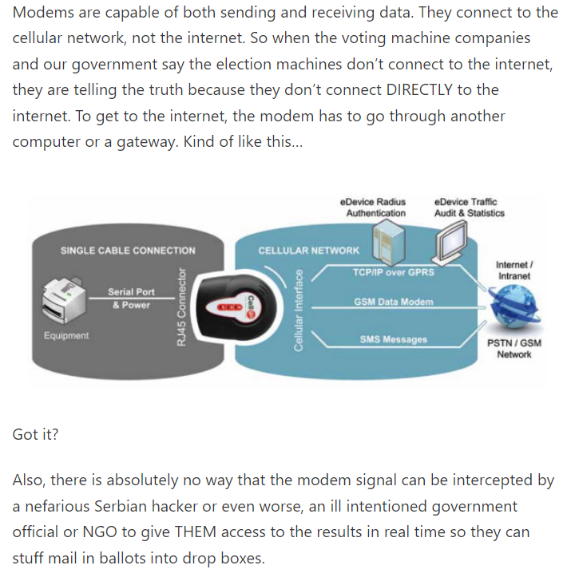

https://electiondataanalyzer.substack.com/p/voting-machine-modems-are-definitely

